Geometry: Unit 5, Lesson 2
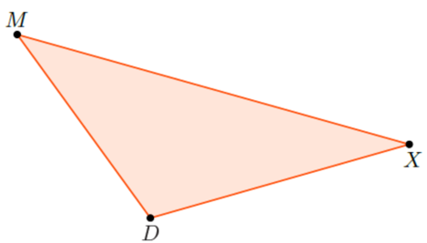
- Triangle $MXD$ is shown. What is the included angle of sides $\overline{MX}$ and $\overline{XD}$?

$$∠MXD$$
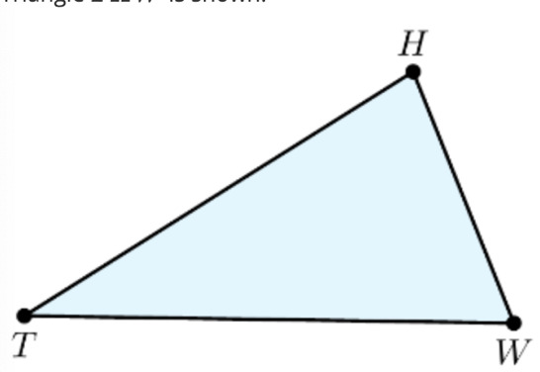

- Triangle $THW$ is shown. To construct triangle $LKR$, a copy of triangle $THW$, using a compass and a straightedge, first you must use a compass to copy $\overline{TW}$ to construct $\overline{LR}$ so that $\overline{TW}≅\overline{LR}$. What do you have to copy so that $∠HTW≅∠KLR$ in step 2?

$$∠HTW$$
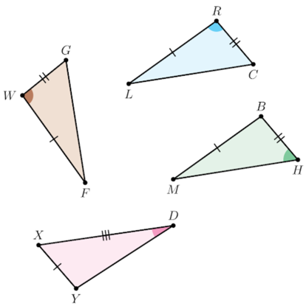
- Triangles $RCL$, $GWF$, $XDY$, and $MHB$ are shown. What is a congruence statement that can be proven by SAS congruence?

$$∆FWG≅∆LRC$$

